**Task1**

1. **Describe the evolution of modern programming languages.**
2. **Define API, JDK, IDE, and other key terms related to Java programming.**

**API (Application Programming Interface):** It's a collection of prewritten building blocks, like classes and interfaces, that provide specific functionalities. You can leverage these functionalities in your code without reinventing the wheel. Java comes with a rich standard library API, but there are also third-party APIs for various purposes.

**JDK (Java Development Kit):**

This is your development workbench. It includes the tools you need to write, compile, and run Java programs. The JDK houses the Java compiler that translates your human-readable code into bytecode, a format the Java Virtual Machine (JVM) understands. It also includes a debugger for troubleshooting and other helpful utilities.

**IDE (Integrated Development Environment):** An IDE is your command center for Java development. It provides a comprehensive environment with features like code editing, syntax highlighting, code completion, project management, and integration with the JDK tools. Popular IDEs for Java include IntelliJ IDEA, Eclipse, and NetBeans. While you can technically use the JDK tools from the command line, an IDE streamlines the development process significantly.

**JVM (Java Virtual Machine):** It is a Java's execution environment. It acts like a virtual computer, translating platform-neutral bytecode into instructions the underlying system understands. This enables "Write Once, Run Anywhere" (WORA) for Java programs.

1. **Identify common uses for the Java programming language. (Applications)**

* **Web Applications:** Java servlets and frameworks like Spring enable developers to create dynamic web applications that run on servers. These web applications can handle complex user interactions and data processing.
* **Android Development:** Though Kotlin is gaining popularity, Java remains a prominent language for developing Android applications. The Android SDK is based on Java, and a vast amount of Android code is written in Java.
* **Big Data and Machine Learning:** Java frameworks like Apache Spark and H2O provide tools for distributed data processing and building machine learning algorithms. These frameworks can handle massive datasets efficiently.
* **Embedded Systems:** A subset of Java, called Java ME, is used for programming embedded systems like routers and medical devices. Java ME offers a lightweight environment suitable for resource-constrained devices.
* **Scientific Computing:** Java libraries like SciJava offer functionalities for scientific computing and data analysis. Scientists can leverage these libraries for numerical computations, data visualization, and simulations.
* **Desktop Applications:** While less prominent now, Java can still be used to develop desktop applications with graphical user interfaces (GUIs). These applications can run on various operating systems thanks to Java's platform independence.

1. **Define key syntactical elements in Java.**
2. **Illustrate the difference among syntax, runtime, and logic errors using examples.**
3. **Syntax Error:**

**Description:** A violation of the language's grammar rules. The code can't be understood by the compiler/interpreter due to incorrect syntax.

1. Write Java programs that take from the user the values of x, n and y and print z=3x*n+5y/2x+3n.

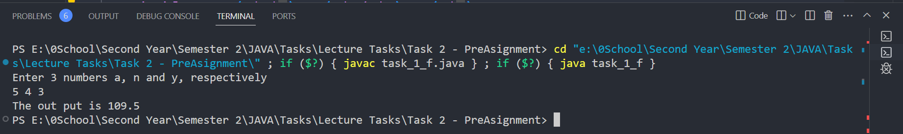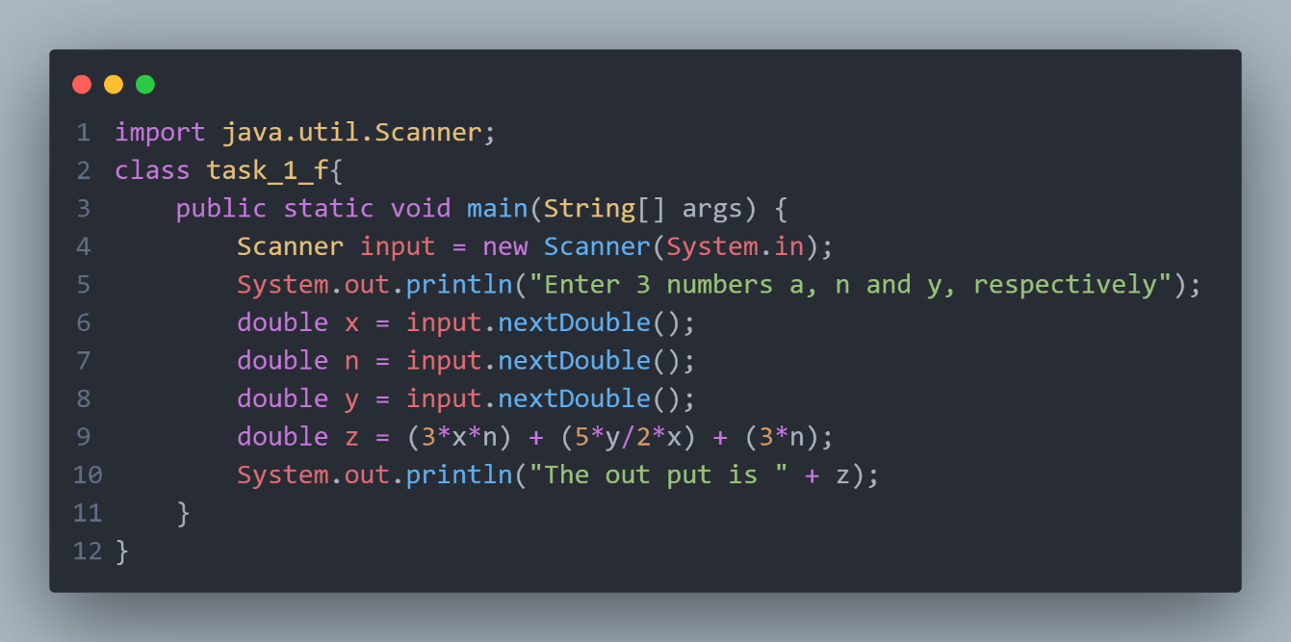

1. Describe the syntax of all selections and loops in the Java programming language.
2. Describe the effect of the Java™ keywords break and continue when used in a loop.
3. Apply Java™ naming conventions to variables, constants, methods, and classes using examples.
4. Predict the behavior of selections and loops using the flowcharts.

**Task 2**

Write, compile, and execute a simple Java program that prints the string “ New Cairo Technological University - Faculty of Industry & Energy Technology- Information and communications technology”.

1. Create a programming environment using an IDE and the Java Development Kit. Then, implement the above program in this environment.
2. Implement a java program in 5 ways. This program takes from a user the grades of students in 6 courses to compute the sum of grades for all students (hint the number of students is unknown).

**Task 3**

Explain the programming style with an Example of Documentation, Vertical Alignment, Comments, Indentation, Meaningful Identifier Names Consistently Typed, and Appropriate use of Typedef with an Example